Compound measures

Speed, Distance and Time

Where rounding is necessary in this exercise, round to 1 decimal place.

1) Find the average jogging speed, in km/h, of the following students.
(a) Amanda jogs 18km in 3 hours.
(b) Amy jogs 8km in 1 hour 15 minutes.
(c) Kayla jogs 9km in 1½ hours.

2) Lex walks 8km in 1 hour 40 minutes. Find Lex's average speed.

3)

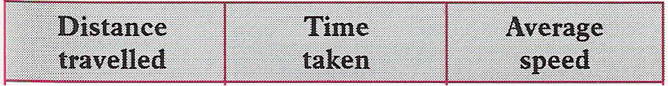
100km | 1 hr 30 min
100km | 1 hr 45 min
100km | 1 hr 20 min
100km | 1 hr 25 min

This table shows the time taken for four different cars to travel 100km from Oxford to Birmingham. Copy and complete this table.
4) A student runs the 100m in 28 secs. What is this student's average speed in m/s?

5) Another student runs the 400m in 1 min 15 sec. What is this student’s average speed, in metres per second, for the 400m?

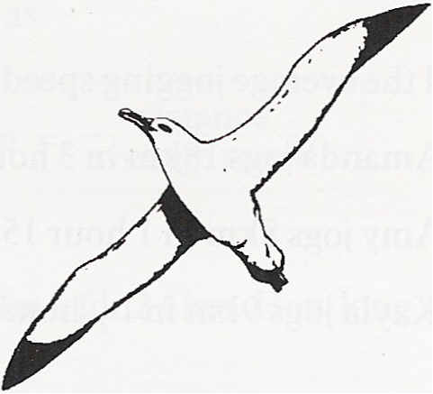
6) A runner sets out at midday to run to the next village, a distance of 12km. She wants to arrive at this village at 1330 hours. At what average speed should she run?

7) An albatross is cruising at an average speed of 90km/h. What distance does the albatross cruise in
(a) 2 hours
(b) three-quarters of an hour?

8) Annabel ran a road race at an average speed of 10km/h. She completed this race in 2 hours 15 minutes.
How long was this road race?

9)

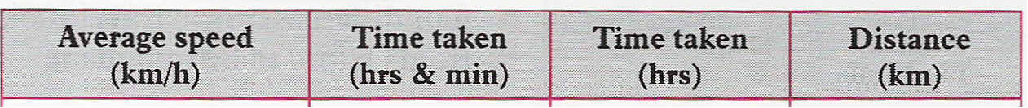
80 | 2 hr 30 min
70 | 4 hr 15 min
90 | 1 hr45 min
60 | 2 hr 12 min
50 | 1 hr 36 min

Copy and complete this table.

10) A train is travelling at 120km/h. How far does this train travel between 0720 hours and 0800 hours?
Density, Mass and Volume
1) A 30cm³ piece of lead has a mass of 345g. What is the density of this lead?

2) The mass of a 1200 ml block of ice is 1104 grams. Find the density of the ice.

3) A piece of cork weighs 10kg. Its volume is 0.04m³. Find the density of this cork.
4) Two models are cast from metal.
One model is made from 40cm³ of brass. This model weighs 340g.
The other model is made from 50cm³ of iron. This model weighs 375g.
Find the densities of the two metals used in the models.

5) A stone weighs 4.4kg.

(a) What is the mass of this stone in grams?
(b) Find the volume (in cm³) of this stone if its density is 2.2g/cm³.
6) The density of mercury is 14.6g/cm³.
How many ml of mercury weighs 73 grams?
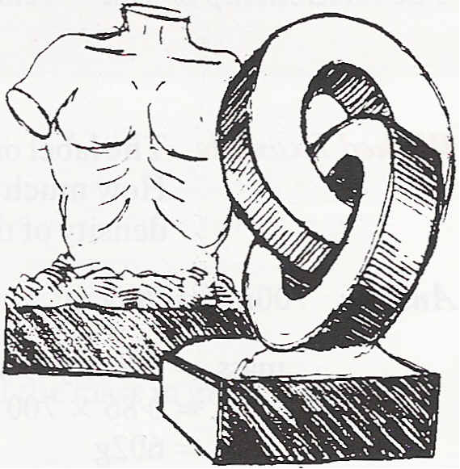
7) A statue is made from clay of density 1.4g/cm³.
Another statue is carved from wood of density 0.8g/cm³.
Both statues are weighed to find their masses.
The wooden one is found to have a mass of 4500g. The clay one has a mass of 7700g.
Which statue has the greater volume?
8) The density of glass in an ornament is 2.5g/cm³. Michaela finds the volume of this ornament to be 45cm³. She then calculates its mass. What answer should she get?

9) Water has a density of 1g/cm³.
How much does 1.5 litres of water weigh?

EXAM QUESTIONS

1. (a) Joanna travels a distance of 75 miles at an average speed of 30 miles per hour. How long does the journey take?
(b) Write down an expression for the time taken to travel a distance of x miles at an average speed of
s miles per hour.

2. (a) State an appropriate degree of accuracy for the time in seconds of a competitor in a 100m race at the Olympic games.
(b) Distance = speed x time.
Calculate the distance of the race run by a competitor at an average speed of 7.8m/s in a time of 51.27 seconds.
(c) Give your answer to an appropriate degree of accuracy.

